
Failover Clustering in Windows Server 2008 R2
White Paper

Published: April 2009

For the latest information, please see:
http://www.microsoft.com/windowsserver2008/en/us/failover-clustering-main.aspx

This is a preliminary document and may be changed substantially prior to final commercial release of the software described herein.
The information contained in this document represents the current view of Microsoft Corporation on the issues discussed as of the date of publication. Because Microsoft must respond to changing market conditions, it should not be interpreted to be a commitment on the part of Microsoft, and Microsoft cannot guarantee the accuracy of any information presented after the date of publication.
This white paper is for informational purposes only. MICROSOFT MAKES NO WARRANTIES, EXPRESS OR IMPLIED, IN THIS DOCUMENT.
Complying with all applicable copyright laws is the responsibility of the user. Without limiting the rights under copyright, no part of this document may be reproduced, stored in, or introduced into a retrieval system, or transmitted in any form or by any means (electronic, mechanical, photocopying, recording, or otherwise), or for any purpose, without the express written permission of Microsoft Corporation.
Microsoft may have patents, patent applications, trademarks, copyrights, or other intellectual property rights covering subject matter in this document. Except as expressly provided in any written license agreement from Microsoft, the furnishing of this document does not give you any license to these patents, trademarks, copyrights, or other intellectual property.
© 2009 Microsoft Corporation. All rights reserved.
Microsoft, Active Directory, Hyper-V, Windows, Windows NT, Windows PowerShell, Windows Server, Windows Vista, and the Windows logo are either registered trademarks or trademarks of Microsoft Corporation in the United States and/or other countries.

Table of Contents
Overview 4
Introducing Windows Server 2008 R2 5
A Brief Overview of Failover Clustering 5
Failover Clustering in Windows Server 2008 8
Simplified Setup and Migration 8
Built-in Cluster Validation Tool 11
Multiple-Site Clusters 12
Storage Improvements 13
New Backup and Restore Functionality 14
Enhanced Security Features 14
Scalability 16
Expanded Networking Functionality 16
Cluster Troubleshooting 17
New for Failover Clustering in Windows Server 2008 R2 18
Enhanced Validation 18
Windows PowerShell Cmdlets 18
Read-Only Application Programming Interfaces 19
Network Prioritization 19
ETW Logging Channels 19
Improved Migration of Cluster Workloads 19
Support for Additional Clustered Services 20
Failover Clustering and Hyper-V 21
Cluster Shared Volumes 21
Live Migration 24
Summary 25
Related Links 26

Overview
The world is now a “24x7” global marketplace, and keeping mission-critical applications, services, and data highly available around the clock is a primary objective of successful IT departments. There is an increasing reliance on technology for business operations, and organizations depend on their systems to be “up” at all times. When services are down, business continuity is interrupted, resulting in significant losses for an organization. IT departments realize that high availability should be designed into systems up front, not added simply as an afterthought.
Windows Server Failover Clustering (WSFC) is a feature that can help ensure that an organization’s critical applications and services, such as e-mail, databases, or line-of-business applications, are available whenever they are needed. Clustering can help build redundancy into an infrastructure and eliminate single points of failure. This, in turn, helps reduce downtime, guards against data loss, and increases the return on investment.
Windows Server® 2008 R2, like its predecessors, has been designed with high availability in mind. It provides customers with ready and convenient access to a host of features and technologies, such as failover clustering, that enhance the availability of the server infrastructure.
Microsoft® Cluster Services (MSCS) was first introduced in Windows NT® 4.0 Enterprise Edition. Over the years, MSCS has been significantly improved, and with Windows Server 2008, it is called Windows Server Failover Clustering (WSFC).
In Windows Server 2008, virtually every component of failover clustering has been enhanced, and unnecessary details have been simplified. Many of the clustering “nuts and bolts” are now hidden behind the new GUI. A failover cluster expert is no longer required to successfully deploy and maintain a failover cluster—an IT generalist can use the new wizard-based approach. While experts can maintain the same level of control they had in previous versions, there is much greater flexibility in how the failover cluster is managed in Windows Server 2008 R2.
Failover clustering also makes economic sense. Failover clustering is included in the enhanced-capability editions of Windows Server 2008 R2—Windows Server® 2008 R2 Enterprise, Windows Server® 2008 R2 Datacenter, and Windows Server® 2008 R2 for Itanium-Based Systems Ease of deployment and affordability make each of these editions of Windows Server 2008 R2 an ideal HA solution for organizations of all sizes.

Introducing Windows Server 2008 R2
Windows Server 2008 R2 is the newest Windows Server operating system and the successor to Windows Server 2008. It builds on the foundation of Windows Server 2008, expanding existing technology and adding new features to enable IT professionals to increase the reliability and flexibility of their server infrastructures. New virtualization tools, Web resources, and management enhancements help save time, reduce costs, and provide a solid foundation for enterprise workloads. Tools—such as Internet Information Services (IIS) version 7.0 and Hyper-V™ technology—combine to provide greater control, increased efficiency, and the ability to react to front-line business needs faster than previous Windows Server versions.

A Brief Overview of Failover Clustering
Failover clusters provide support for mission-critical applications—such as databases, messaging systems, file and print services, and virtualized workloads—that require high availability, scalability, and reliability.

How Failover Clusters Work
A failover cluster is a group of independent computers, or nodes, that are physically connected by a local-area network (LAN) or a wide-area network (WAN) and that are programmatically connected by cluster software. The group of nodes is managed as a single system and shares a common namespace. The group usually includes multiple network connections and data storage connected to the nodes via storage area networks (SANs). The failover cluster operates by moving resources between nodes to provide service if system components fail.
Normally, if a server that is running a particular application crashes, the application will be unavailable until the server is fixed. Failover clustering addresses this situation by detecting hardware or software faults and immediately restarting the application on another node without requiring administrative intervention—a process known as failover. Users can continue to access the service and may be completely unaware that it is now being provided from a different server (see Figure 1).
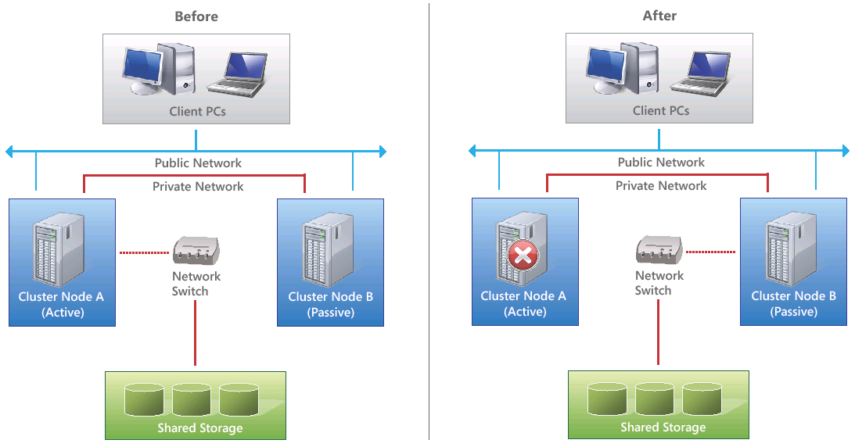
Figure 1. Failover clustering

Failover Clustering Terminology
The following terms and concepts are used in failover clustering:
- Resource. A hardware or software component in a failover cluster (such as a disk, an IP address, or a network name).
- Resource group. A combination of resources that are managed as a unit of failover.
- Dependency. An alliance between two or more resources in the cluster architecture.
- Quorum. A shared view of members (nodes and some resources) in a cluster. To ensure that only one subset of cluster members is functioning at one time, a majority of members is required to be active and in communication with each other. This avoids having two subsets of members both attempting to service a request and writing to the same disk, a situation which could cause corruption. Each node provides a single vote toward membership. A physical disk or a file share may also serve as a quorum resource and contribute a single vote toward membership.
- Heartbeat. The cluster’s health-monitoring mechanism between cluster nodes. This health checking allows nodes to detect failures of other servers in the failover cluster by sending packets to each other’s network interfaces.
- Membership. The orderly addition and removal of nodes to and from the cluster.
- Global update. The propagation of cluster configuration changes to all cluster members.
- Cluster registry. The cluster database, stored on each node and on the quorum resource, maintains configuration information (including resources and parameters) for each member of the cluster.
- Virtual server. A combination of configuration information and cluster resources, such as an IP address, a network name, and application resources.
- Active/Active failover cluster model. All nodes in the failover cluster are functioning and serving clients. If a node fails, the resource will move to another node and continue to function normally, assuming that the new server has enough capacity to handle the additional workload.
- Active/Passive failover cluster model. One node in the failover cluster typically sits idle until a failover occurs. After a failover, this passive node becomes active and provides services to clients. Because it was passive, it presumably has enough capacity to serve the failed-over application without performance degradation.
- Shared storage. All nodes in the failover cluster must be able to access data on shared storage. The highly available workloads write their data to this shared storage. Therefore, if a node fails, when the resource is restarted on another node, the new node can read the same data from the shared storage that the previous node was accessing. Shared storage can be created with iSCSI, Serial Attached SCSI, or Fibre Channel, provided that it supports persistent reservations.

A Little History – Failover Clustering in Windows Server 2008
A major challenge with failover clusters has historically been their complexity: to build, to configure, and to manage. This has too often resulted in higher-than-necessary costs for organizations: customers have lost opportunities to make more of their applications highly available, and organizations have dedicated some administrative resources to maintaining the clusters that they have deployed, rather than to the applications hosted by those clusters.
In Windows Server 2008, the improvements to failover clusters are aimed at simplifying clusters, at making them more secure, and at enhancing cluster stability. Windows Server 2008 failover clusters are easy to procure, easy to create, easy to use, and easy to manage. Security and networking has also been improved, as has the way a failover cluster communicates with storage. Windows Server 2008 failover clusters can also support more nodes than previous Windows Server versions. These improvements combine to make failover clustering a smart business choice, delivering high availability technology as a part of the operating system.

Simplified Setup and Migration
Windows Server 2008 includes a new, easy-to-use management interface. The previous cluster administration interface has been replaced with a Microsoft Management Console (MMC) 3.0 snap-in, the Failover Cluster Management snap-in (CluAdmin.msc). This interface is accessible from within Administrative Tools (see Figure 2). It is also possible to open a blank MMC and then add this snap-in along with any others.

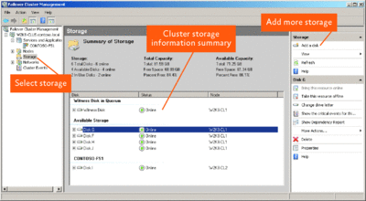
Figure 2. New management interface
The Failover Cluster Management snap-in is designed to be task oriented instead of cluster resource oriented, as it was in previous versions of failover clustering. Administrators can select the clustering task that they want to undertake (such as making a file share highly available) and supply the necessary information by using the wizard. Administrators can even manage Windows Server 2008 failover clusters remotely from Windows® 7-based or Windows Vista®-based client computers by installing the Remote Server Administration Tools.
In previous versions of cluster administration, the procedure for creating a highly available file share was a complex process. The administrator had to create a group, a disk resource, an IP address resource, and a resource name (a network name). Then, the administrator had to configure IsAlive/LookAlive, configure preferred services, and finally set dependencies.
With Windows Server 2008 failover clustering, it is not necessary to deal with resources or dependencies. Instead, administrators can start the High Availability Wizard (see Figure 3). They are then asked for a client access point name (the network name). They do not need to assign an IP address, as Windows Server 2008 failover clustering supports DHCP (and DHCP addressing for resources is the default in the wizard).

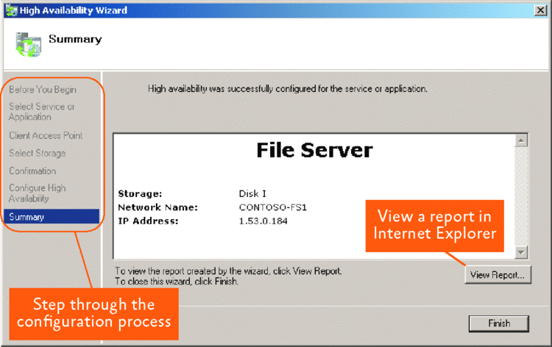
Figure 3. High Availability Wizard

The High Availability Wizard creates a group, takes a disk from available storage (which is automatically detected), and then moves the disk to that group. Then, the wizard creates an IP address resource and creates a network name resource (based on client access point entry). It defines the resource owners, the preferred owner, and the dependencies automatically. However, administrators retain the ability to adjust these settings manually.
In addition, multiple failover clusters throughout the organization can be managed from a single MMC. And since the Failover Cluster Management snap-in is a true MMC, it is possible to create custom management consoles that include the Failover Cluster Management snap-in in addition to other management snap-ins.
Experienced cluster server administrators may want full access to all of the commands that they had available in the command-line tool. They can fine-tune their failover clusters by using the Cluster.exe command-line tool. Moreover, Windows Server 2008 failover clusters are fully scriptable with Windows Management Instrumentation (WMI).
Note that due to the architectural changes in failover clustering, in-place or rolling upgrades from Windows Server 2003 are not supported. While a wizard-based migration process has been included to help, migrating to a Windows Server 2008 failover cluster will, nonetheless, require some planning.

Built-in Cluster Validation Tool
A built-in validation process is included in failover clustering to make it easier for customers to know that their cluster configuration will be supported. Customers can select their hardware and then run the Validate a Configuration Wizard (also known as Validate). If the clustered hardware components have the Windows Server 2008 logo and the entire configuration passes all of the validation tests, the cluster configuration is fully supported. There is no longer a separate, specific hardware compatibility list for clustering.
This validation process consists of a series of tests that are grouped into four main categories: inventory, network, storage, and system configuration. Figure 4 shows the expanded network category.

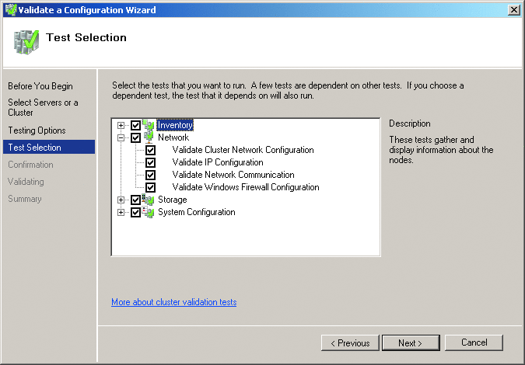
Figure 4. Validate a Configuration Wizard
The validation results are HTML based for easy collection and remote analysis. The wizard takes just a few minutes to run, although this is a function of how many nodes are in the failover cluster and how many logical unit numbers (LUNs) are exposed to the servers. Once you create the failover cluster, you can use the Validate a Configuration Wizard as a powerful diagnostic tool to maintain the failover cluster and to identify potential problems.
Note that when you run the Validate a Configuration Wizard, some tests may not pass, but clustering may still be installed and function. For example, not conforming to a cluster configuration best practice, such as having only one network interface card (NIC) in each node, will raise a warning rather than an error. But, the failover cluster will function. However, passing the Validate a Configuration Wizard is the standard for support for failover clusters in Windows Server 2008: If a failover cluster does not pass the wizard, it is not supported by Microsoft. In addition, running the Validate a Configuration Wizard does not release the customer from the responsibility of using only hardware and software that are certified under the Windows Server Logo Program for Windows Server 2008.
You can also use the Validate a Configuration Wizard to troubleshoot in-production failover clusters. If you were to experience a problem with your failover cluster, this wizard is the first thing you would want to run to ensure that everything is functioning as expected. This may help reduce your organization’s support costs. You can also avoid running the storage tests against an in-production failover cluster to keep your resources online.
While many customers believe the added flexibility of a support policy based on logo’d hardware and the validate tool is helpful, some customers want an additional level of confidence that what they buy will be supported – before they buy it. For customers who want that assurance that their cluster configuration will be supported before purchasing, Microsoft has created the Failover Cluster Configuration Program (FCCP). Server vendors who are members of the FCCP list pre-configured, tested and validated hardware configurations on their websites.

Multi-Site Clusters
Multiple-site failover clusters are easier to deploy and much more technically feasible with Windows Server 2008 failover clustering.
Prior to Windows Server 2008, the options for deploying failover clusters that were geographically dispersed were limited. These options involved very specific prequalified array-based replication technologies. Multiple-site failover clusters were restricted to certain environments due to the latency requirements and the requirement that the cluster nodes all reside in the same subnet.
Windows Server 2008 affords much more flexibility in implementing multiple-site failover clusters. For example, administrators no longer have to stretch virtual local area networks (VLANs) across the WAN to accommodate geographically distant servers that are on different subnets; failover cluster nodes can now reside on completely different subnets. The introduction of “OR” logic allows the use of two IP addresses. This means that the IP addresses can reside in different subnets across a routed network, eliminating the need to create VLANs.
Moreover, the network latency requirements in Windows Server 2003 server clustering, which required a round-trip latency of less than 500 milliseconds (msec), have been removed from Windows Server 2008 failover clustering. The failover clustering requirement for the heartbeat—the process by which cluster nodes signal their integrity to one another—has also become fully configurable. Heartbeats are now tunable so that high-latency networks are supported when you deploy multiple-site failover clusters.

Storage Improvements
Windows Server 2008 failover clusters are designed with built-in support for SANs.
In Windows Server 2003, the cluster disk driver was in a direct path to the storage. However, in Windows Server 2008, the cluster disk driver (Clusdisk.sys) is completely rewritten and is now a true Plug and Play (PnP) driver. The cluster disk driver now communicates with the partition manager driver (Partmgr.sys) to interact with storage (see Figure 5).

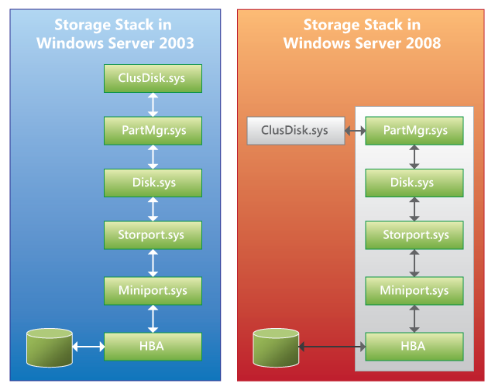
Figure 5. Storage stack in Windows Server 2008 and in Windows Server 2003

The partition manager has the primary responsibility of protecting cluster disk resources. All disks on a shared storage bus are automatically placed in an offline state when they are first mapped to a cluster node. This allows storage to be simultaneously mapped to all the nodes in a failover cluster even before the failover cluster is created, saving time. Once storage is added to a failover cluster, the disks show a status of “Reserved” in Disk Management, and they are never left in an unprotected state.
There is also a change to the SCSI commands. In Windows Server 2003, SCSI-2 Reserve/Release commands were used, with the cluster disk driver writing to sectors on the disk itself. In Windows Server 2008, SCSI SPC-3 Persistent Reservation commands are required (this is verified by the Validate a Configuration Wizard). Cluster nodes must register before they are allowed to place a reservation on the storage, and cluster nodes periodically defend their reservations by using the Registration Defense Protocol.
In Windows Server 2008, disks are never left in an unprotected state. This significantly reduces the possibility of corruption. In addition, GUID partition table (GPT) disks are now supported, and multiple-terabyte storage (larger than 2 terabyte LUNs per partition) is now natively possible.
Additional storage improvements include an improved check disk process (Chkdsk.exe), built-in disk repair functionality that was previously part of the Cluster Server Recovery Utility (ClusterRecovery.exe), and self-healing disks. In Windows Server 2008 failover clusters, the disk signature and the LUN ID are both used when identifying a cluster disk resource. If either of these has changed, the cluster configuration is updated. This translates into a reduction in the errors that are simply due to an attribute change on a physical disk resource.

New Backup and Restore Functionality
Windows Server 2008 features a closer integration with the Volume Shadow Copy Service (VSS) for easier backups. Failover clustering in Windows Server 2008 has its own VSS writer, which enables VSS backup applications to more easily support failover clusters. Backing up the cluster configuration is straightforward—as long as the system state is part of a backup, the cluster configuration can be restored.

Enhanced Security Features
Windows Server 2008 failover clusters feature several new security enhancements. Perhaps the most significant is that the Cluster service no longer runs under the context of a domain user account (or the Cluster service account). In Windows Server 2003 and in previous versions of Windows, a domain user account was required during the configuration process and was used to start the Cluster service. It was added to the local Administrators group on each node of the cluster and was given the required local user rights to allow the Cluster service to function properly. As a domain user account, the Cluster service account was subject to a number of domain-level policies that could be applied to cluster nodes, and these policies could cause the Cluster service to fail.
The Cluster service in Windows Server 2008 runs under the local system account with a specific set of rights on the local cluster node that allows it to function properly. The security context for the failover cluster is now the Cluster Name Object (CNO), the computer object that is created by default in the Computers container in Active Directory® when the failover cluster is first created. Since a domain user account is no longer used for the Cluster service, the CNO is used for all operations that require security inside the failover cluster.
Failover clusters also add Virtual Computer Objects (VCOs), which are additional computer objects created in the Computers container in Active Directory. VCOs equate to the cluster network name resources that are created as part of client access points (CAPs) in the failover cluster. The CNO is responsible for creating all VCOs in a failover cluster and therefore must have the domain-level right to create computer objects on the container where the VCOs are created; the CNO is added to the system access control list (SACL) for the object in Active Directory (see Figure 6).
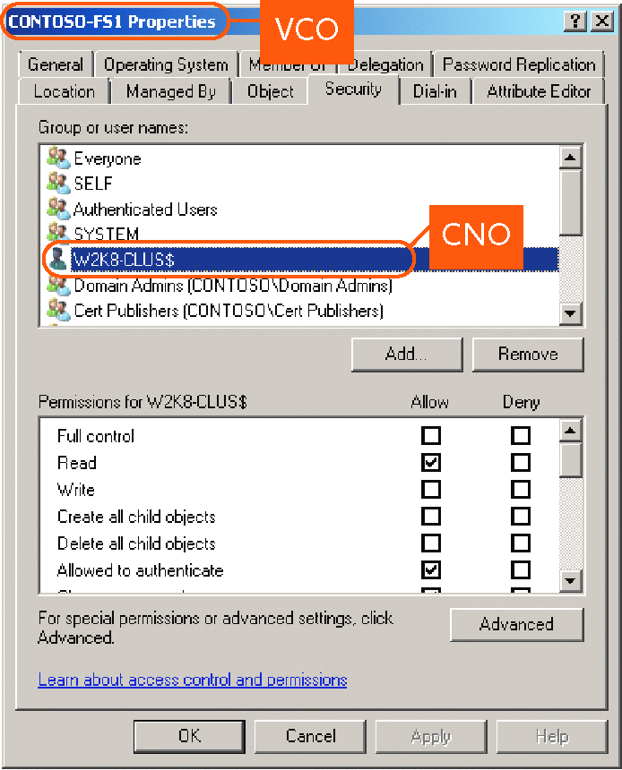
Figure 6. Virtual Computer Objects properties

Kerberos is used in Windows Server 2008 failover clustering as the default authentication method. However, should an application that is not able to use Kerberos for authentication ever need to access cluster resources, failover clusters still have the ability to use NTLM authentication.
Finally, all communication between the nodes is now signed by default. By using the Cluster.exe command-line tool, you can change this cluster property so that all communication between the nodes is encrypted to provide an additional level of security.

Scalability
Windows Server 2008 failover clusters can support more nodes than clusters in previous versions of Windows. Specifically, x64-based failover clusters support up to 16 nodes in a single failover cluster in Windows Server 2008 Enterprise or in Windows Server 2008 Datacenter, as opposed to the maximum of 8 nodes in Windows Server 2003.
In addition to support for more cluster nodes, Windows Server 2008 failover clusters now support GPT disks. A GPT disk uses the GPT disk partitioning system. A GPT disk offers these benefits:
- It allows up to 128 primary partitions. (MBR disks can support up to four primary partitions and an infinite number of partitions inside an extended partition.)
- It allows a much larger volume size—greater than 2 terabytes (the limit for MBR disks).
- It provides greater reliability due to replication and cyclical redundancy check (CRC) protection of the partition table.
The combination of an increased number of nodes and support for GPT disks greatly enhances the scalability of larger volumes in failover cluster deployments.

Expanded Networking Functionality
New networking capabilities enable more flexibility when designing high availability and disaster recovery solutions in Windows Server 2008 and provide more reliable connectivity among the nodes in the failover cluster. The cluster network driver has been completely rewritten so that it provides highly reliable and fault-tolerant communication among the nodes in a failover cluster, provided that each node is connected to at least two separate and distinctly routed networks.
Cluster nodes can also obtain IP address information via DHCP (Dynamic Host Configuration Protocol). The configuration of a cluster node's network interfaces determines which networks will use static or dynamic IP addresses. Even if an IP address resource in a failover cluster is obtained from a DHCP server, it can be changed to a static IP address in the Failover Cluster Management snap-in.
Multicast functionality has been discontinued in Windows Server 2008 failover clustering, and cluster communications now use User Datagram Protocol (UDP) unicast. (Port 3343 is still the common port that is used by Microsoft failover clusters.) There are now new messaging processes that are internal to the Cluster service itself. When nodes transmit and receive heartbeats to confirm that each node is still available, the nodes use Transmission Control Protocol (TCP) rather than the less reliable UDP.
Because Windows Server 2008 supports Internet Protocol version 6 (IPv6), the Cluster service will support this functionality as well. This includes being able to support IPv6 IP address resources and IPv4 IP address resources either alone or in combination in a failover cluster.
Failover clustering also supports 6-4 and Intra-site Automatic Tunneling Addressing Protocol (ISATAP). Additionally, failover clustering supports only IPv6 addresses that allow for dynamic registration in Domain Name System (DNS) (AAAA host records and the IP6.ARPA reverse look-up zone). Currently, there are three types of IPv6 address types—global, site local, and link local. Dynamic DNS registrations will not occur for link local addresses and therefore cannot be used in a failover cluster.

Cluster Troubleshooting
Instead of working with the text-file-based cluster log, an administrator can use Event Tracing for Windows (ETW) to easily gather, manage, and report information about the sequence of events that occurred on the failover cluster. Default log sizes vary, and you can modify the default log sizes by using the failover cluster installation logs.

New for Failover Clustering in Windows Server 2008 R2
Improvements to failover clustering were also added in Windows Server 2008 R2. These improvements focus primarily on the new Cluster Shared Volumes (CSV) feature and on Windows PowerShell, the new scripting language for clustering technologies.

Enhanced Validation
Windows Server 2008 R2 includes enhancements to the Validate a Configuration Wizard (Validate), such as a set of new tests called the Cluster Configuration tests. These tests help check settings that are specified within the failover cluster and the cluster resources, such as the settings that affect how the failover cluster communicates across the available networks. The Cluster Configuration tests can also be used to review and archive the configuration of the clustered services and applications (including settings for the resources within each clustered service or application) to ensure that best practices are being employed.
The enhanced validation tests let you fine-tune a cluster configuration, track the configuration, and identify potential cluster configuration issues before they cause downtime.

Windows PowerShell Cmdlets
Windows Server 2008 R2 introduces Windows PowerShell as the new scripting language for clustering technologies and begins the move away from the Cluster.exe command-line tool, which will be deprecated in the next Windows Server release. Windows PowerShell uses consistent syntax and naming patterns across roles and features and provides numerous benefits over standard command-line interfaces, including easily customizable scripts and the dynamic use of variables.
Cmdlets form the basis of the Windows PowerShell instruction set. The new cmdlets for failover clusters provide powerful ways to script cluster configuration and management tasks. By using Windows PowerShell, you can perform virtually all the operations that you can perform in the Failover Cluster Management snap-in.
Note that you can use the Cluster.exe command-line tool in Windows Server 2008 R2, but Windows PowerShell will be the only command-line interface available for failover clusters in future releases of Windows Server.

Read-Only Application Programming Interfaces
Windows Server 2008 R2 introduces read-only APIs, a security enhancement that allows administrators to query the state of the failover cluster and its resources without performing any actions. Read-only APIs are ideal for a first-level triage to "look, but not touch."

Network Prioritization
Windows Server 2008 R2 enhances network prioritization. It lets an administrator plan an internal cluster network for efficiency by giving the fastest network the highest priority for internal traffic (such as heartbeat, Cluster Shared Volumes, and live migration traffic, which are discussed later in this paper).

ETW Logging Channels
The text-file-based cluster log that is used in Windows Server 2003 is gone. Event trace logging (.etl) is now enabled through Event Tracing for Windows (ETW), new functionality that is built in to the command line. The Cluster.exe command-line tool lets an administrator dump the trace log into a text file. Then, the administrator can use the cluster.exe Log /Generate command to see this log. Also, the administrator can create diagnostic views inside the improved Windows Server 2008 Event Viewer.

Improved Migration of Cluster Workloads
To migrate cluster workloads that are currently running on Windows Server 2003, Windows Server 2008, or Windows Server 2008 R2 to Windows Server 2008 R2, administrators can use the Migration Wizard, which is built in to the Failover Cluster Management snap-in.
The migration process:
- Supports every workload that is currently supported on Windows Server 2003 and on Windows Server 2008. The wizard can migrate settings from the following resource groups:

  - File server
  - DHCP
  - Generic Application
  - Generic Script
  - Generic Service
  - Windows Internet Name Service (WINS) Server
  - Distributed File System Namespace (DFS-N)
  - Distributed Transaction Coordinator (DTC)
  - Internet Storage Name Service (iSNS) Server
  - Message Queuing (also called MSMQ)
  - Network File System (NFS)
  - Other Server (client access point and storage only)
  - Remote Desktop Connection Broker

- Supports most common network configurations.
- Does not support rolling upgrades of failover clusters. Cluster workloads must be migrated to a new failover cluster that is running Windows Server 2008 R2. All other workloads have their own cluster-aware migration/upgrade process.

Support for Additional Clustered Services
Windows Server 2008 R2 provides support for two additional clustered services.

DFS-Replication Support
DFS-Replication is an efficient, multiple-master replication engine that is used to keep folders synchronized between servers across limited bandwidth network connections. In Windows Server 2008 R2, you can configure member servers in a replication group to be highly available for uninterrupted and failure-resilient replication services.

Remote Desktop/Terminal Services Support
The Remote Desktop Connection Broker supports session load balancing and session reconnection in a load-balanced remote desktop server farm, ensuring that clients are reconnected to their same session or virtual machine. The Remote Desktop Connection Broker is also used to provide access to Windows Server 2008 R2 RemoteApp programs and virtual desktops through RemoteApp and Desktop Connection.

Failover Clustering and Hyper-V
One of the marquee features in Windows Server 2008 R2, Live Migration, uses the new Cluster Shared Volumes (CSV) feature within the failover clustering role in Windows Server 2008 R2. Server virtualization is provided by a new version of Hyper-V.

Cluster Shared Volumes
Cluster Shared Volumes (CSV), which functions as a distributed-access file system that is optimized for Hyper-V, is a significant architectural innovation incorporated in failover clustering in Windows Server 2008 R2 Enterprise and in Windows Server 2008 R2 Datacenter, as well as in Microsoft Hyper-V Server 2008 R2.
Unlike a Clustered File System (CFS), CSV does not use a specialized proprietary file system—it uses the standard NTFS file system, so it requires nothing additional to purchase or support. Regular clustering storage devices can be used—Fibre Channel, iSCSI, or Serial Attached SCSI—as long as these devices receive a logo for Windows Server 2008 R2 and the complete solution passes the Validate a Configuration Wizard.
With CSV, any node in a failover cluster can access the shared storage and any node can host virtual machines, regardless of which node “owns” (or manages NTFS on) the storage (see Figure 7). CSV provides many benefits, including easier storage management, greater resiliency against failures, and the ability to store many VMs on a single LUN and have them fail over individually. Most notably, CSV provides the infrastructure to support and enhance live migration of Hyper-V virtual machines.

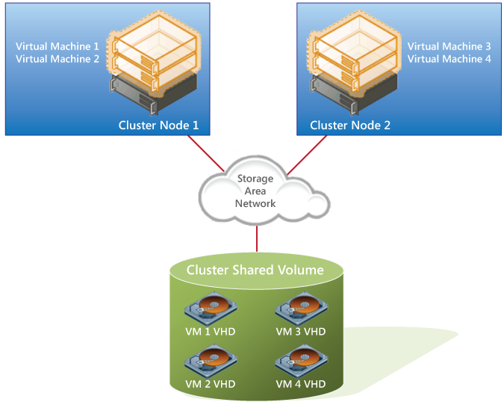
Figure 7. Cluster Shared Volumes

Because CSV provides a consistent file namespace to all the nodes in the failover cluster, any files that are stored on CSV have the same name and path from any node in the failover cluster. CSV volumes are stored as directories and subdirectories beneath the %SystemDrive%\ClusterStorage root folder, as illustrated in Figure 8.
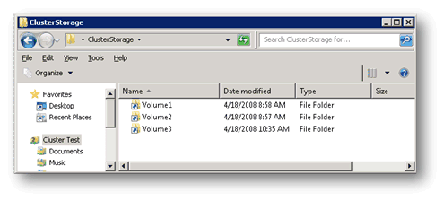
Figure 8. Single namespace in CSV
In Windows Server 2008 and in earlier versions of Windows, each resource group was required to have a physical disk resource to manage the cluster’s access to the application data residing on the shared storage device. This ensured that only one node could access the data at a time. However, since only one node could own the LUN at any time, the LUN was the smallest unit of failover. If any application that was running on the LUN needed to move to another node, all the applications on that LUN would also be failed over. This process incurred some downtime during the failover. Therefore, customers frequently ran only a single application from each LUN so that only that one application would become unavailable during a failover. This added significant complexity to storage management—clusters with hundreds of resources needed hundreds of LUNs, which were then challenging to deploy and manage.
CSV breaks the dependency between application resources (the virtual machines) and disk resources; it does not matter where a disk is mounted because it will appear local to all the nodes in the failover cluster. However, the applications on that CSV disk can run on any node at any time.
CSV manages storage access differently than regular clustered disks do (see Figure 9). A node is designated as a “coordinator node”—this can be any node in a failover cluster. When an application needs to write data to the CSV disk, the application requests permission from the coordinator node. If the data being written does not require changing the file system structure, the coordinator node sends the addresses of the writable blocks, letting the VM write directly to the file system (direct access to the LUN). If the data requires a change to the file system structure—for example, an extension, a move, or a change in the attributes of a file—the coordinator node writes the data to the disk. In this way, the coordinator node ensures that access to the NTFS file system is controlled to help prevent corruption.
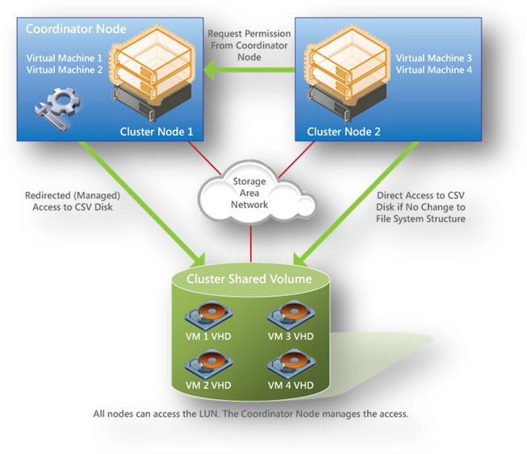
Figure 9. Coordinator node in CSV

Live Migration
Live migration is enhanced by CSV within failover clustering in Windows Server 2008 R2. Live migration and CSV are separate but complimentary technologies: they can work independently, but CSV enhances the resilience of live migration and is thus recommended (not required) for live migration. The CSV volumes enable multiple nodes in the same failover cluster to concurrently access the same LUN. From the perspective of the VMs, each appears to actually own a LUN; however, the .vhd files for each VM are stored on the same CSV volume.
CSV is the enabling technology for live migration with Hyper-V. With CSV, moving a virtual machine between physical servers happen in milliseconds—without dropped network connections or perceived downtime. Migration operations become virtually invisible to connected users.
Once you establish a failover cluster of physical servers that are running Hyper-V, VMs can be “live migrated” at will. In the event of a node failure, VMs are restarted on another cluster node.

Summary
Failover clusters are used by IT professionals who need to provide high availability for services or applications; failover clusters help IT departments keep their mission-critical services up and running.
In Windows Server 2008 R2, the improvements to failover clusters are aimed at simplifying failover clusters, making them more secure, and enhancing their stability. Cluster setup and management are easier. Security and networking in failover clusters have been improved, as has the way a failover cluster communicates with storage.
In addition to the enhancements in failover clustering, the new virtualization tools, Web resources, and management enhancements help save time, reduce costs, and provide a solid foundation for enterprise workloads. Windows Server 2008 R2 gives customers greater control, increased efficiency, and the high availability that is needed to succeed in today’s global marketplace.

Related Links

The following Web pages provide additional information.

For the Windows Server 2008 home page, visit:
http://www.microsoft.com/windowsserver2008/en/us/default.aspx

For the clustering and high availability blog, visit:
http://blogs.msdn.com/clustering/default.aspx

For more information about the Windows Server 2008 Failover Cluster Configuration Program, visit:
http://www.microsoft.com/windowsserver2008/en/us/failover-clustering-program-overview.aspx

